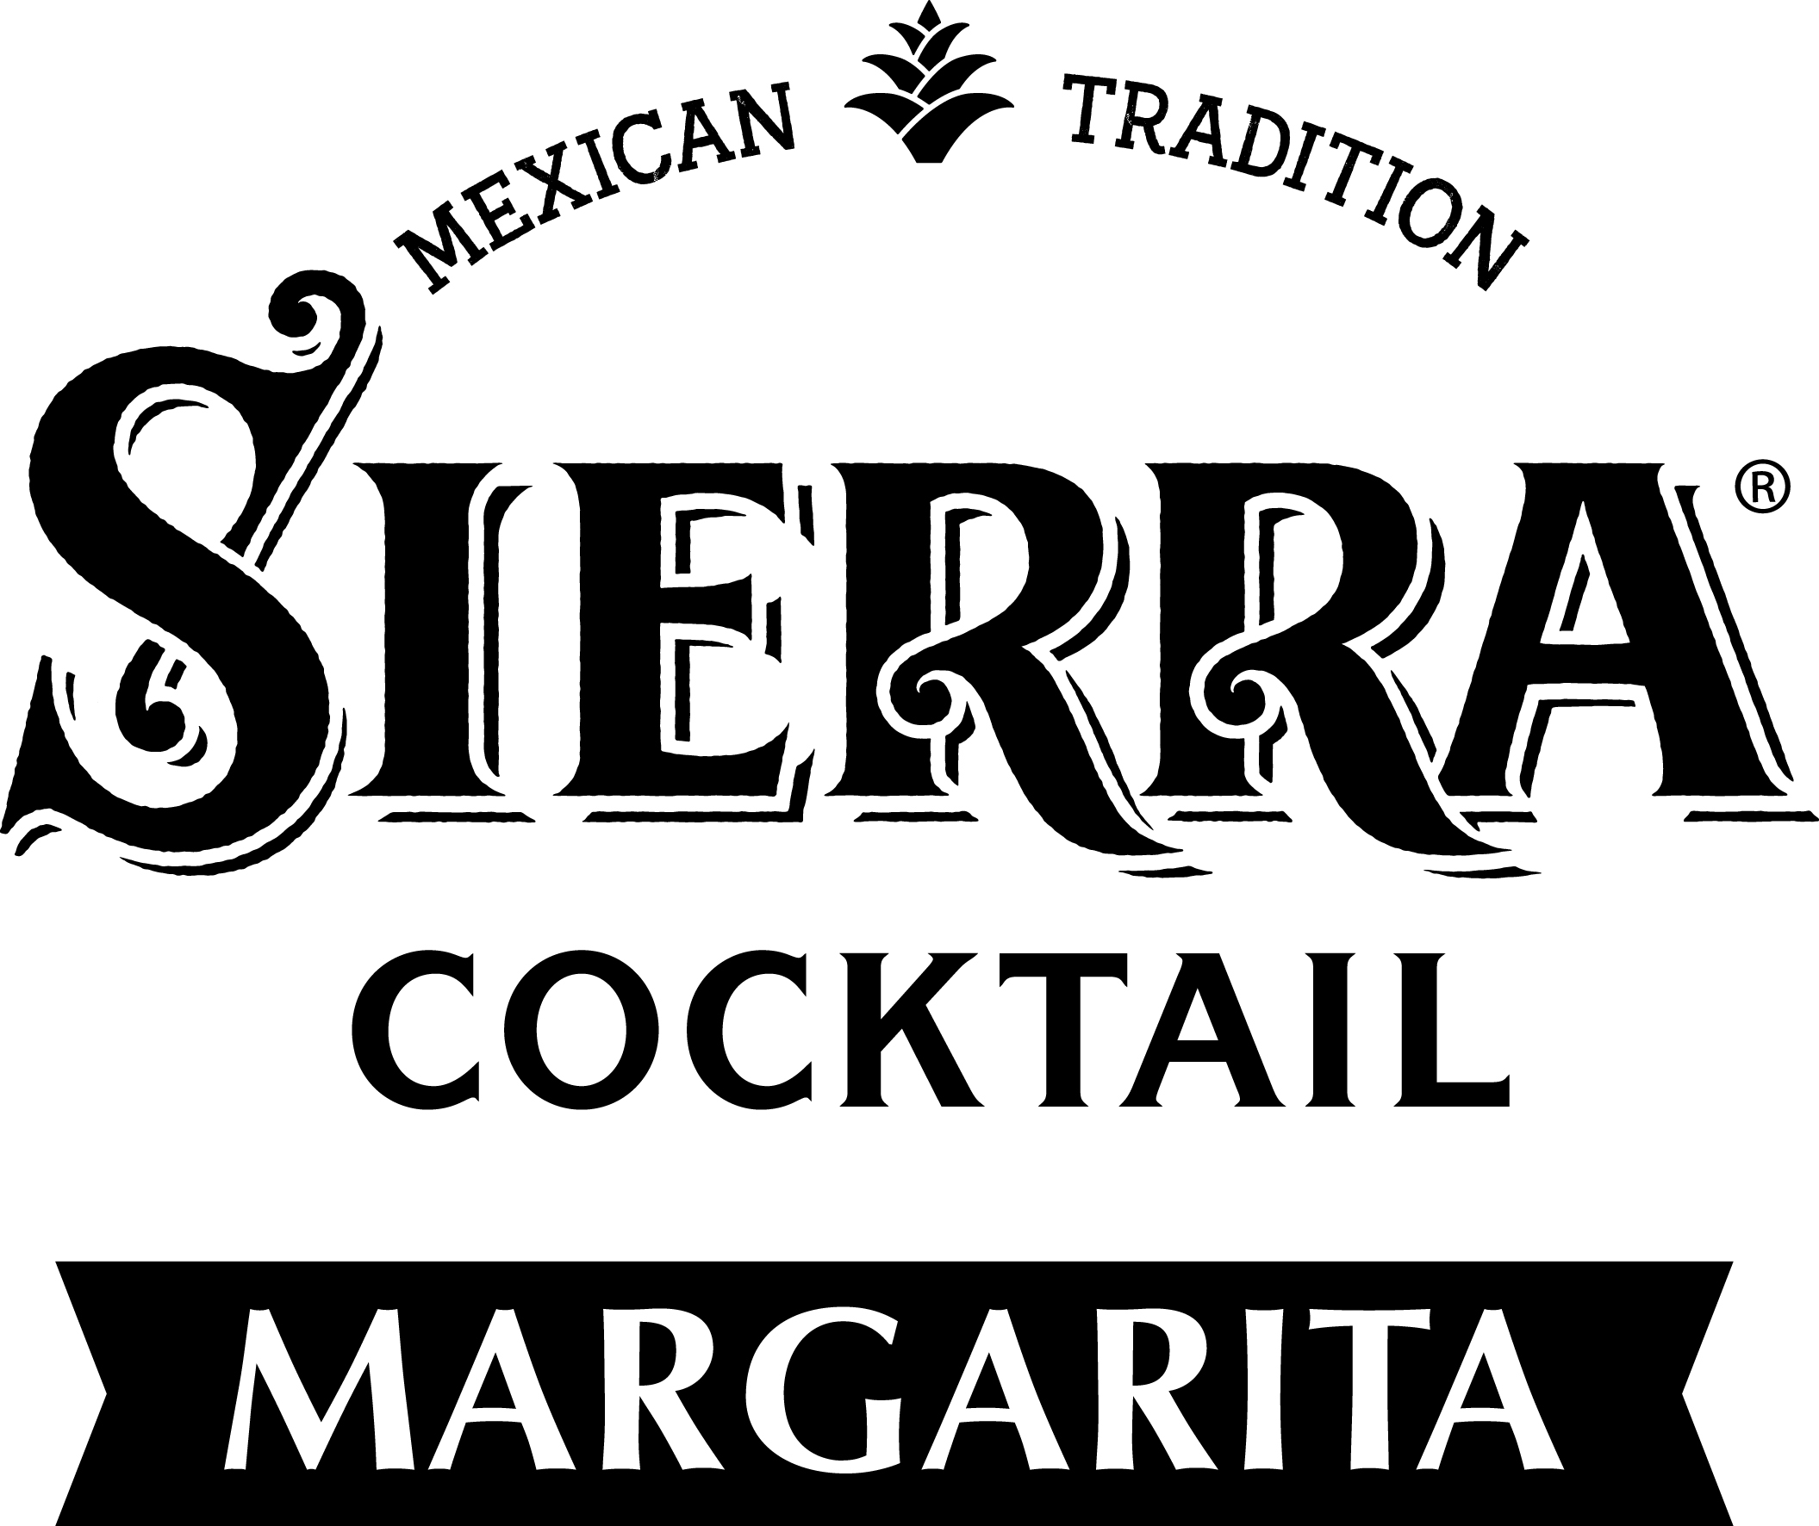

SIERRA Tequila to launch ready-to-drink Margarita for export markets
Hamburg, June 2018. The family-run spirits company BORCO-MARKEN-IMPORT, with SIERRA Tequila Europe’s market leader in the Tequila category, expands its international portfolio by launching the ready-to-drink SIERRA Tequila Margarita as of July 1st, 2018. For decades SIERRA Tequila has been taking the world by storm and has been establishing a remarkable following due to its excellent taste and vibrant brand identity. It is distributed in over 90 countries across the globe and is market leader in many of them; a pioneer in making the thriving Mexican culture accessible beyond Mexican borders. Inspired by the legendary Tommy’s Margarita, the SIERRA Tequila ready-to-drink Margarita with SIERRA Tequila Silver, fresh lime juice and agave syrup provides an immersive taste experience. Every single sip of the SIERRA Tequila Margarita reveals an exciting, passionate world. A world shaped by freshness and a comforting sea breeze. Dr. Tina Ingwersen-Matthiesen, shareholder, member of the board and member of the BORCO owner family Matthiesen is delighted by the opportunities the RTD offers: “We are proud to be able to strengthen the most consumed cocktail with our exceptional SIERRA Tequila ready-to-drink Margarita. It opens up new ways to experience our flagship SIERRA Tequila – simple, refreshing and with a fierce Mexican attitude. It is reminiscent of mild summer evenings that are spent with friends under palm trees.”
The SIERRA Tequila ready-to-drink Margarita: A true Mexican
The recipe of the SIERRA Tequila ready-to-drink Margarita draws its unparalleled character from the use of only natural ingredients. SIERRA Tequila Silver’s rich, fruity body couples with fresh lime juice and agave syrup, supplemented by a pinch of sea salt to create depth and a balanced profile. The SIERRA Tequila ready-to-drink Margarita is produced according to highest quality standards and is certified by the Consejo Regulador del Tequila (CRT) which is responsible for keeping an eye on the global production of Tequila products.
The natural, Mexican ingredients are mirrored in the design of the 330ml can which creates a modern look and weaves the Mexican origins of the Margarita cocktail into the 21st century. Its green color scheme shines just as bright as the Mexican sun and supports the extraordinary freshness of the Margarita. Beyond question, the famous brand icon, the red SIERRA Tequila sombrero, which adorns every bottle of SIERRA Tequila Silver, is incorporated into the design as well. The ABV is 4,9% alc./vol.
A journey to the origin of the Margarita cocktail
She’s from Mexico, Señores, and her name is the Margarita Cocktail – and she is lovely to look at, exciting and provocative“. These words were employed by the American magazine ESQUIRE in 1953 in order to introduce its cocktail of the month. The origin of the Margarita cocktail has been subject of many discussions and stories. Among the most charming ones is the tale of a Mexican bartender who fell in love with a beautiful Hollywood diva. Rumor has it that he crafted a drink with Tequila, lime juice, liqueur and sea salt to worship her stunning beauty. With its remarkable look and salt rim the drink soon became popular as what is now considered to be the classic Margarita; a cocktail that is one of the most popular and consumed ones across the bar scene around the world.

Best Serve:
Fill a Margarita glass with ice and add SIERRA Tequila ready-to-drink Margarita. Garnish with a lime wheel.
On that note: ¡Pa’ arriba, pa’ bajo, pa’l centro, pa’ dentro!

About SIERRA Tequila:
Mexico is the country of vibrant soulfulness. In the past years its colorful culture has become an important part of contemporary lifestyle in Europe and across the world. Mexican food, Mexican music, Día de Muertos inspired make up and Tequila are popular more than ever. SIERRA Tequila is distributed in over 90 countries across the world and is in many of them market leader. It is the number 1 Tequila in Europe, number 2 outside the Americas and number 3 in Duty Free. Besides a strong brand position in Europe, the award winning SIERRA Tequila is popular in many countries abroad, ranging from Australia and China to Thailand. The exceptional quality of SIERRA Tequila Silver was awarded a silver medal both at the renowned International Wine & Spirit Competition 2017 and at this year’s SPIRITS BUSINESS Tequila Masters.

BORCO-MARKEN-IMPORT, Hamburg
SIERRA Tequila is owned by BORCO-MARKEN-IMPORT based in Hamburg. BORCO is one of the largest German and European producers and distributors of top international spirit brands. The portfolio of the family-run and independent company covers almost all key international segments and is certainly unique in terms of its strength and unity.

For further information please contact:
BORCO-MARKEN-IMPORT Matthiesen GmbH & Co.KG
Winsbergring 12 – 22, 22525 Hamburg
Telefon: (040) 85 31 6-0
Telefax: (040) 85 85 00
E-Mail: infoline(at)borco.com
www.borco.com

