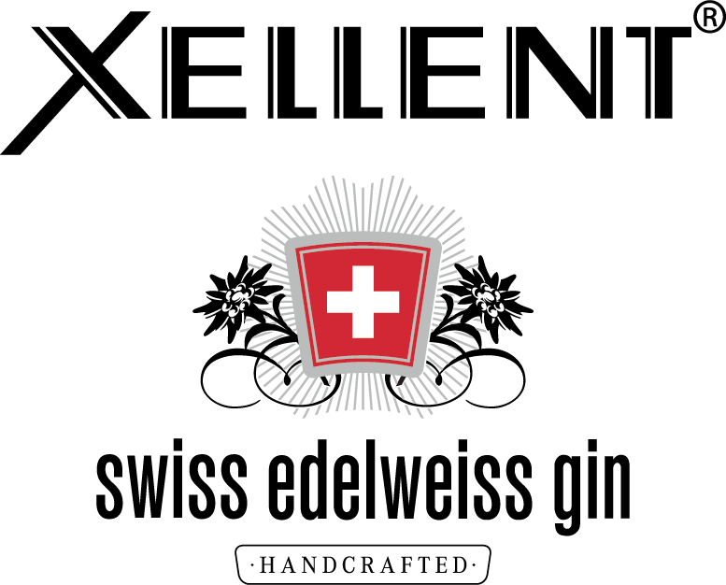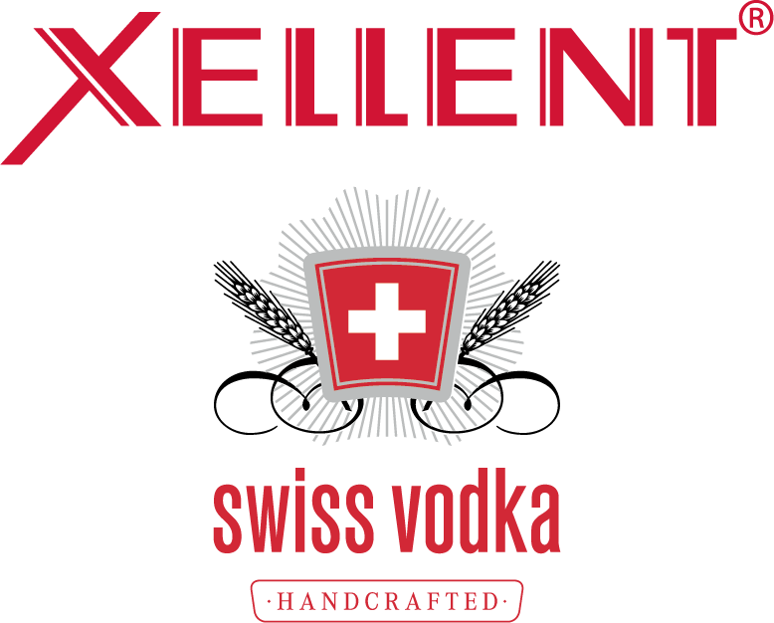

BORCO takes over global distribution of XELLENT Swiss Vodka and XELLENT Edelweiss Gin
Hamburg, November 2018. The family-run spirits company BORCO unveils the latest additions to its renowned international spirits portfolio (except Germany, Austria and Switzerland): XELLENT Swiss Vodka and XELLENT Edelweiss Gin, both owned and produced by one of Switzerland’s leading spirits producers and distributors DIWISA Distillerie Willisau SA. By adding both brands that showcase excellent craftsmanship, BORCO strengthens its international portfolio significantly. Dr. Tina Ingwersen-Matthiesen, member of the owner family and member of the board of the family-run spirits company BORCO-MARKEN-IMPORT, is delighted to take over the distribution: “Both XELLENT Swiss Vodka and XELLENT Edeweiss Gin have been awarded internationally and embody Swiss craftsmanship and precision. We are thrilled to make XELLENTs flavor profile accessible all over the world with the help of a strong network and thank DIWISA for their trust.” Adrian Affentranger, owner and CEO of DIWISA Distillerie Willisau SA, is also pleased and considers BORCO to be the ideal fit in order to promote the exceptionality of XELLENT in different parts of the world: “BORCO is the perfect partner in order to show and establish both the craftsmanship and the unique character of XELLENT on an international level, with the help of an exceptional feel for the market. We are very proud of this partnership.”
XELLENT Swiss VODKA: Passion meets elaborate craftsmanship
This typical Swiss vodka is the result of the finest raw materials, passionate master distillers and careful craftsmanship with a 100 years old history. Love, time and passion are needed for producing vodka with a distinct character. Paired with expertise, XELLENT Swiss vodka comes to life. Much like the inhabitants of the Lucerne hinterland, XELLENT Swiss Vodka also has its rough edges. That is just the way it is supposed to be, because vodka should help to flavor a drink. Top-quality work is required in this respect, from the local cereal farmer to the bottle.
During the entire production process regional roots, a down-to-earth attitude and transparency are key and play a vital role. The mash is manufactured from scratch using high-quality bread-grade rye of the “Matador” and “Picasso” varieties. They are cultivated by 18 farmers in the Napf region, right in the heart of Central Switzerland. Small-scale cultivation makes it possible to carefully handle the plants and harvest them at optimum ripeness. The water used is also a key ingredient, sourced from the Titlis Glacier. The glacier water is soft and contains oxygen and minerals, all of which give XELLENT its unique flavor. By using only the best raw materials, the high quality of XELLENT Swiss vodka can be ensured.
The mash forms the basis for making the vodka and is produced in a process requiring elaborate craftsmanship. To produce the first raw spirit of XELLENT, the mash is distilled using the traditional pot still method. In the second distillation phase, the raw spirit is purified in a reflux still consisting of a small copper column with 45 plates. This step is followed by a third distillation phase which further refines the flavor. Eventually, XELLENT presents itself with 40% ABV.

Tasting Notes:
Whether in a cocktail or pure on the rocks: XELLENT Swiss Vodka should be fun to drink and its diversity of flavor should come through. Elegant and with character – it’s as simple as that.
NOSE: fruity, with cherry notes, stimulatingly nutty, slight rye flavour; mixture of perfectly blended fresh aromas
MOUTHFEEL: elegant, well-balanced attack on the palate; first silky smooth and gentle notes of rye, then boiled cherry essence, followed by full-bodied and concentrated, slightly nutty rye flavour, producing a sophisticated bouquet full of character
FINISH: fruity, nutty, well-balanced interplay of acidity in a long-lasting finale

XELLENT Edelweiss GIN: Inspired by herbs and plants from the company’s own garden
The basis for XELLENT Edelweiss Gin is XELLENT Swiss Vodka, which is refined by the expertise and passion of the master distiller for herbs and plants from the company’s own garden. Prior to distillation, the ingredients are soaked in vodka for several hours. This enables the aromas and flavors of juniper berries and herbs like lemon balm, edelweiss, woodruff and lavender to fully develop. Careful distillation and the addition of glacier water are key factors in producing XELLENT Swiss Edelweiss Gin with 40% ABV.
Tasting Notes:
NOSE: fresh to refreshing, with fragrances of citrus, floral aromas and fine hints of juniper berry
MOUTHFEEL: soft and mellow with spicy components
FINISH: a touch of lemon balm, fresh

About DIWISA Distillerie Willisau SA
XELLENT Swiss Vodka and XELLENT Edelweiss Gin are both one of the major spirits owned by DIWISA Distillerie Willisau SA. DIWISA is a leading Swiss company involved in the development and marketing of progressive beverage brands steeped in tradition which provide moments of pleasure, joie de vivre and a basis for joint celebrations. It has been committed to providing the best service for the long-term success of our business partners for 100 years. The portfolio of DIWISA includes national and internationally renowned brands from different spirits categories and countries. The important own brands Distillerie Willisau, Trojka, Trojka Energy, Paesanella and Tucanocan be found in the portfolio as well as global players: SIERRA Tequila, Fisnbury Gin, Russian Standard Vodka, Champagne Lanson and Jägermeister form a strong lineup, completed by various other distribution brands.

BORCO-MARKEN-IMPORT, Hamburg
BORCO is one of the largest German and European producers and distributors of top international spirit brands. The portfolio of the family-run and independent company, including among others SIERRA Tequila, Yeni Raki, Russian Standard Vodka, Champagne Lanson and the whiskys from Whyte & Mackay, covers almost all key international segments and is certainly unique in terms of its strength and unity.

For further information please contact:
BORCO-MARKEN-IMPORT Matthiesen GmbH & Co.KG
Winsbergring 12 – 22, 22525 Hamburg
Phone: (040) 85 31 6-0
Telefax: (040) 85 85 00
E-Mail: infoline@borco.com
www.borco.com

